Logan Fields

Carolyn Garvin

Charles Brooks

CSCI-C200-13886

Fall 2017

**Team 1 Final Project Documentation**

**Work Time Log:**

Logan 11/18 11:30am-11:50am

Team meeting 11/19 3:45pm-4:10pm

Logan 11/19 4:30pm-6:30pm, 7:40pm-8:10pm, 10:45pm-11:20pm

Logan & Carolyn 11/19 11:45pm-12:05am

Carolyn 11/20 12:05am-1:30am

Charles 11/20 11:50 am -12:05 pm

Charles & Logan 11/20 2:30pm-3:00pm

Charles 11/20 9:15pm- 9:35pm

Charles 11/22 12:00am-12:30 pm

Logan 11/23 2:30pm-4:40pm

Logan 11/27 11:15am-11:40am

Carolyn 11/28 3:45-5:00

Charles 11/28 3:45-5:30

Logan 11/29 12:00pm-1:30pm, 3:00pm-4:00pm

Team meeting 11/30 2:45pm-3:20pm

Team meeting 12/1 12:30pm-2:00pm

Logan 12/1 7:20pm-8:30pm, 11:45pm-12:30am

Team meeting 12/2 3:00pm-5:15pm

Logan & Carolyn 12/2 5:15pm-7:00pm

Logan 12/2 11:00pm-1:00am

Logan 12/3 12:45pm-1:45pm, 4:15pm-5:00pm, 7:00pm-8:30pm

Logan 12/4 7:00pm-7:30pm

Logan 12/5 1:45pm-2:20pm, 5:00pm-5:45pm, 11:00pm-11:15pm

Logan & Charles 12/5 3:10pm-3:45pm

Carolyn 12/5 6:30pm - 11:32 pm

Logan 12/6 11:45am-11:55am, 2:20pm-3:25pm, 9:00pm-10:30pm

Logan 12/7 2:00pm-2:30pm, 7:30pm-8:00pm

Team work 12/7 2:45pm-3:45pm

Team meeting 12/9 5:00pm-7:00pm

Logan 12/9 8:00pm-8:15pm

Charles 12/11 6pm - 7:10pm

Carolyn 12/13 11pm - 4:00am

Logan & Carolyn 12/14 2:30pm-3:30pm

Logan 12/14 11:00pm-1:30am

**Problem Log:**

-issues implementing portions of the “ball” attributes via class

Solution: bypassed class for problem parts after extensive

debugging/research with no solution by putting them in the main

module and wall module

-issues with image transparency/backgrounds/size

Solution: used online editing tools (lunapic.org) to edit images to have

transparent backgrounds or to be the correct size

-libpng errors given for icons initially in png format

Solution: converted to jpg format to stop error

-issues running program on Charle’s Macbook

Solution: consultation with Larry and the professor to solve image

location issues

-issues during initial implementation of sound files

Solution: researched in StackFlow and other forums and found

conflict between initiation statements in pygame (pygame.init()

requires a screen to be made before it goes on and was stopping

pygame.mixer.init() from processing)

-a large number of minor bugs that were caused by missing syntax -ex: : ] ) ( “-, arguments, index out of range, misspelled variable, and other minor issues

Solution: intense rounds of debugging (usually assisted by Logan)

**Task Breakdown & Assignment Log:**

Milestone 1: Due November 30th 2017, 11:59pm Bulk of code

Task

1.DONE Display brick layer on screen top w/ each brick as an object

Date done: 11/20

Prim. Person in Charge: Tiffany

2.DONE Player paddle at bottom of screen

Date done: 11/20

Prim. Person in Charge: Charles

3.DONE Ball placed randomly between bricks & paddle w/ random initial direction

Date done: 11/23

Prim. Person in Charge: Logan

4.DONE Detection of ball hitting sides & appropriate change in direction

Date done: 11/20

Prim. Person in Charge: Logan

5.DONE Detection of ball hitting ceiling & indic. of level completed

Date done: 11/25

Prim. Person in Charge: Logan/Carolyn

6.DONE Detection of ball hitting floor & indication of level failed

Date done: 11/23

Prim. Person in Charge: Logan

7.DONE Player ability to control paddle via keyboard or mouse interface

Date done: 11/20

Prim. Person in Charge: Charles

8.DONE Change in angle of reflection of ball depending on where it hits player paddle

Date done: 11/23

Prim. Person in Charge:Logan

9.DONE Destruction of a brick when hit by ball

Date done: 11/29

Prim. Person in Charge: Logan

Milestone 2:

-Add level progression - a minimum of five levels of increasing difficulty must be included. Pause between levels and provide control to the user for resuming the next level.

Date done: 12/5

Prim. Person in Charge: Logan

-Images for all the functions ex) play, pause, lives, etc.

Date done: 12/02

Prim. Person in Charge: Carolyn

-Design and implement a score function that adheres to the game objective

(reach the top wall as quickly as possible). This MUST be documented in a

manner that completely captures how the score for your game is calculated.

Date done: 12/6

Prim. Person in Charge: Logan

-Add persistence for the top 10 high-scores/users in old-arcade style fashion:

1 AAA 10,500

2 AAZ 10,000

3 ZCV 850

Maintain the high-score information in a flat file that is loaded at game start-up.

Date done: 12/7

Prim. Person in Charge: Charles & Logan

-Add a main menu game screen.

Date done: 12/02

Prim. Person in Charge: Carolyn

-Add a game screen for viewing the high-scores - scores can only be viewed prior to starting a new game.

Date done: 12/07

Prim. Person in Charge: All Team in Class

-Add a game screen for viewing game-play instructions.

Date done: 12/02

Prim. Person in Charge: Carolyn and Charles

-Add the score, number of lives, and a timer to the display.

Date done: 12/6

Prim. Person in Charge: Logan

-The ball should reset if it touches the bottom of the screen. The number of

lives should decrease and the game should pause until the user starts the

next ball.

Date done: 12/5

Prim. Person in Charge: Logan

-If the ball touches the bottom and the player is out of lives, the game should end with an appropriate message and allow the user to input his or her initials if a high-score has been attained.

Date done: 12/7

Prim. Person in Charge: All Team in Class

Milestone 3: Extra features  
-feature 1  
 +powerups (gotten from breaking specific bricks)  
 >extra life   
 >large paddle (10s)  
 +main person in charge: Carolyn  
 >task breakdown:  
 ~get images  
 ~program bricks to hold powerups  
 ~program powerups to appear upon breaking  
 ~program game to react to powerups   
 +date finished: 12/15  
  
-feature 2  
 +sound  
 >when ball hits bricks/walls/paddle  
 >when ball breaks brick  
 >sound when hits iron bricks  
 +main person in charge: Charles  
 >task breakdown:  
 ~get sounds  
 ~input sounds to game  
 ~program sounds when ball hits wall/paddle/unbroken

brick

~program sounds when brick breaks

+date finished: 12/12

-feature 3  
 +cracked/changing bricks  
 >multihit bricks change pictures when they're hit  
 >if one hit, leave; if two hit, change to cracked then leave after

hit 2; if three hit, change to cracked, change to shattered, then

leave after 3 hit  
 >iron bricks  
+main person in charge: Logan  
 >task breakdown  
 ~get iron bricks image  
 ~get cracked and double cracked bricks  
 ~input images into game  
 ~program image change when relevant  
+date finished:12/11

**Ball Variations:**







**Brick Variations:**



















**Paddles:**





**Pass/Fail Image Variations:**

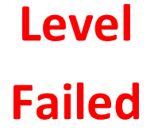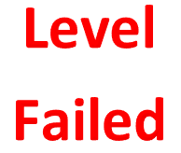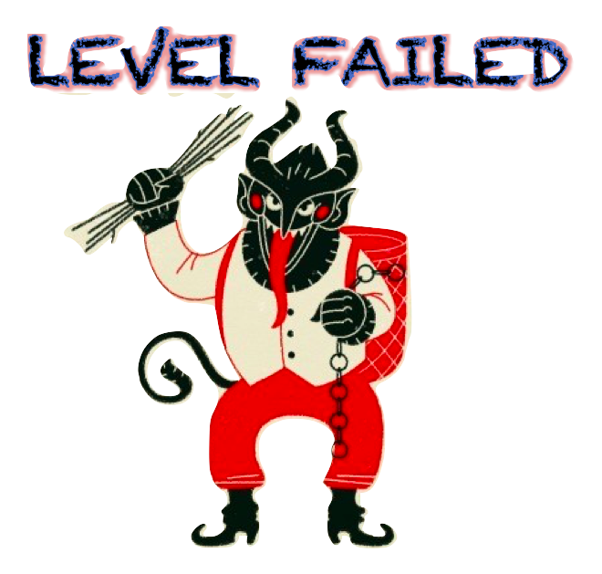

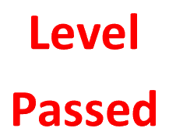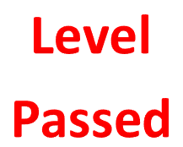

**Icons:**



















**Misc. Resources:**

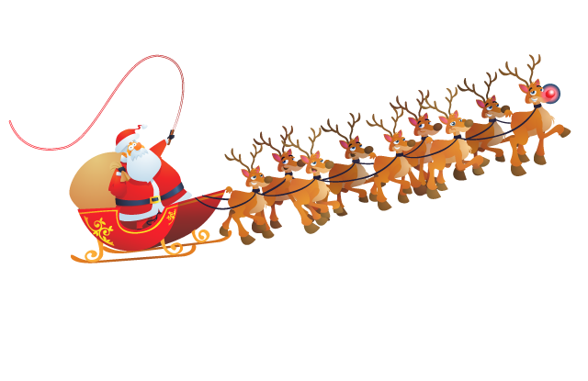

**Notes/Drawings from Papers:**

